**Fashion brands and their Communication Strategies**

One of the latest means of promotion is luxury fashion brands marketing. It helps to achieve success for high-end businesses or companies. It also helps companies to reach more and more people who desire to have luxury products or items. It helps in relating with the people and finding comfort through linking the brands through a digital platform or site or landing page. People can also get connected and adopt these brands from anywhere and at any point in time that will ultimately optimize the revenue of luxury brands. Let’s take the example of **Chanel** and **Hermes**,

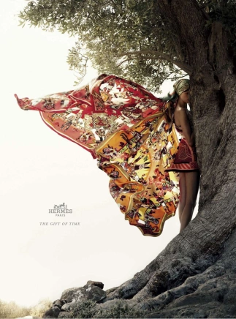

Chanel and Hermès’s communications strategies most clearly contrast with regards to the imagery and tone of their advertising campaigns. Their different brand identities are stark – Hermès prefers campaigHermes-SS12-01ns that reflect its discretion, philosophy, and tradition, while Chanel’s embodies modernity, empowerment and youth. For instance, Hermès campaigns typically depict mystery through dreamlike scenarios set against subtle nature-inspired backdrops. Its strategy involves **rousing curiosity and romanticizing its offering**. The Fall 2009 print campaign featured an igloo made of printed scarves in the snowy wilderness, while that of Spring 2012 featured a model hiding behind a tree with scarves as fairy wings. The mystery and romance of such imagery, which invokes curiosity and seems frozen in time, highlights the brand’s exclusivity and timeless appeal. It invites viewers to linger upon the image and ensures that products take center stage, so that the brand’s unparalleled quality and experience in creating products that withstand the test of time are clearly communicated. Indeed, Hermès campaigns maintain similar aesthetics and do not change frequently according to the seasonal fashion calendar, further emphasizing its products’ lasting value. These factors are aligned with **Hermès’s mysterious identity and supports its principle of creating products that endure, rather than simply seduce**.

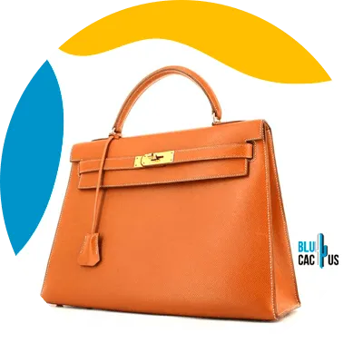

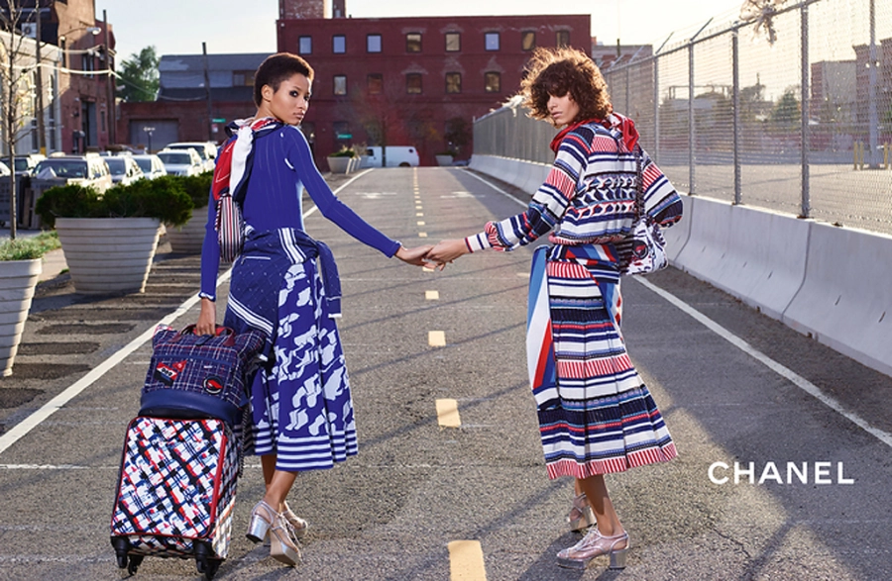

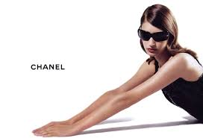

Conversely, **Chanel’s communications strategy** is driven by **exposure to the masses and appealing to customer aspiration**. In particular, its conspicuous and fast-changing campaigns arouse viewers to aspire towards the sophisticated lifestyles that its stylised models embody. Its audacious urban-inspired SS16 campaign, for example, features **vibrant clothing** and **cool-looking models** who seem aloof due to sheer trendiness, and whose confident femininity reflects Chanel’s association with women’s liberation. This explains why the brand is renowned for featuring popular celebrities that embody ambition and transcend conventional conceptions of woman- or manhood in campaigns. Kristen Stewart for instance, Chanel’s brand ambassador and campaign star, **reflects the brand’s DNA through her boyish femininity, cool-girl appeal, and success as a young actress**. Chanel, therefore, strategically appeals to target customers by communicating its own personality through those of well-known celebrities. By featuring celebrities, dramatic imagery, and audacious styling, Chanel’s communications strategy involves **highlighting boldness to distance itself from consumers**, whilst seducing them with aspiration.

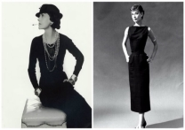

The **main storyline reinforced** throughout the brand’s marketing is that of **a liberated young woman**, in line with its history. In addition to building trust, Chanel’s content is **never about hard selling** its products, but always **about the stories**. Among its competitors, Dior, Hermes and Louis Vuitton, Chanel probably has the most engaging content, with innovative video shorts featuring the likes of Pharrell Williams and Keira Knightley. Chanel manages to keep cementing its positioning as elegant and modern.

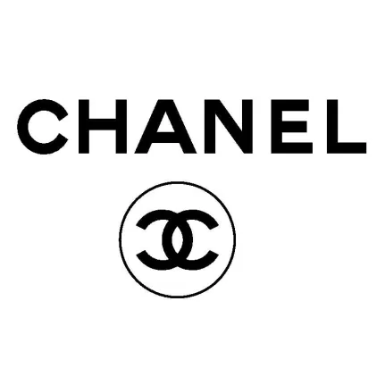

Its **logo’s crossing C’s are instantly recognizable**. Its choice of celebrities continues to embody classic style with a unique personality; counting Penelope Cruz and Margot Robbie among its brand ambassadors.

**Invention of the hands-free bag** – Coco invented the hand-free sling bag to further free women from the hassles of being tied down physically. The iconic 2.55 bag was the first of its kind to allow women to go about their day without **worrying about holding their bags**.

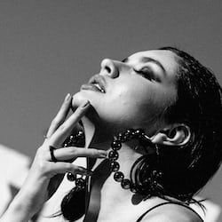

In comparison to other brands the consumer perception of Chanel is <25-50% (slightly negative [45%]) in comparison to other brands. Chanel carries neutral dominance [42%] and is perceived as very feminine.

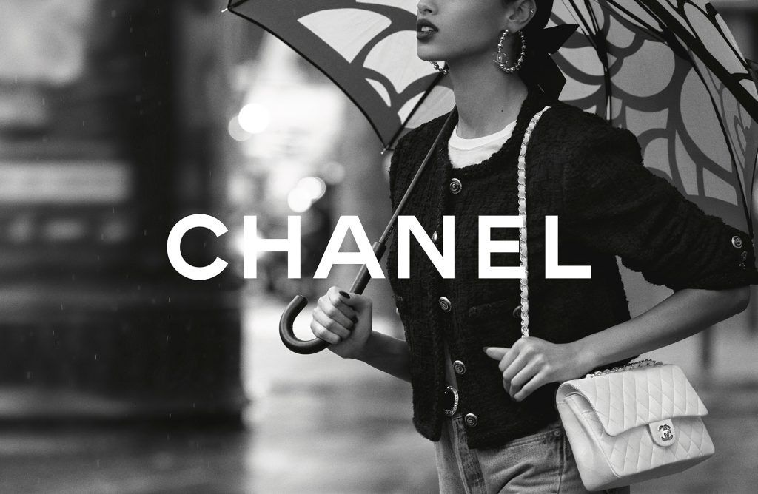

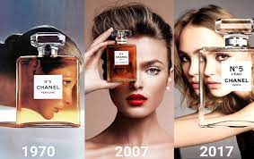

The image demonstrates the coherence in the pattern of advertisement of Chanel.

Other interesting competitors to consider are **Zara** and **H&M**. Zara’s fashion-forward route of flooding the market by creating **aspirational products and campaigns** drove high sell outs even during the work from home era. Products continue to boast a high turnover with subtle discounting and elevated price points. **H&M remains more bullish with discounting**. Its brand positioning in the market is broad, aligning with families and attracting the Gen-Z consumer driven by designer collaboration hype and low prices.

Both brands have starkly different marketing communications, with H&M’s emails often blurring men’s, women’s and childrenswear together to create a family-focused offer. In contrast, Zara sends more targeted and directional emails by age and gender.

Zara relentlessly focuses on the customer. The product creation process of Zara involves customers' needs heavily, and it is at the core of the brand's success today. A fascinating story that can show this is how Zara creates its products to leverage the buyers' input. In 2015, a Zara store in Tokyo received a lady named Miko who asked for a pink scarf, but there was none. The same happened in Toronto, San Francisco, and Frankfurt, with customers asking for a pink scarf but couldn't get one.

7 days later, all Zara stores worldwide started selling pink scarves. 500,000 items were stocked and sold out in just three days. With the right insight at the right time and direct access to the production chain, Zara could launch new designs at lightning-fast speed and provided exactly what customers needed.

With distinct consumer groups in mind, different products are sought after at each brand. While any actions tagged as “**sustainable**” by fast fashion retailers often invite skepticism and greenwashing claims, both retailers’ status in the market will automatically influence competitors to examine their environmental impact and work towards initiatives to benefit people and the planet.

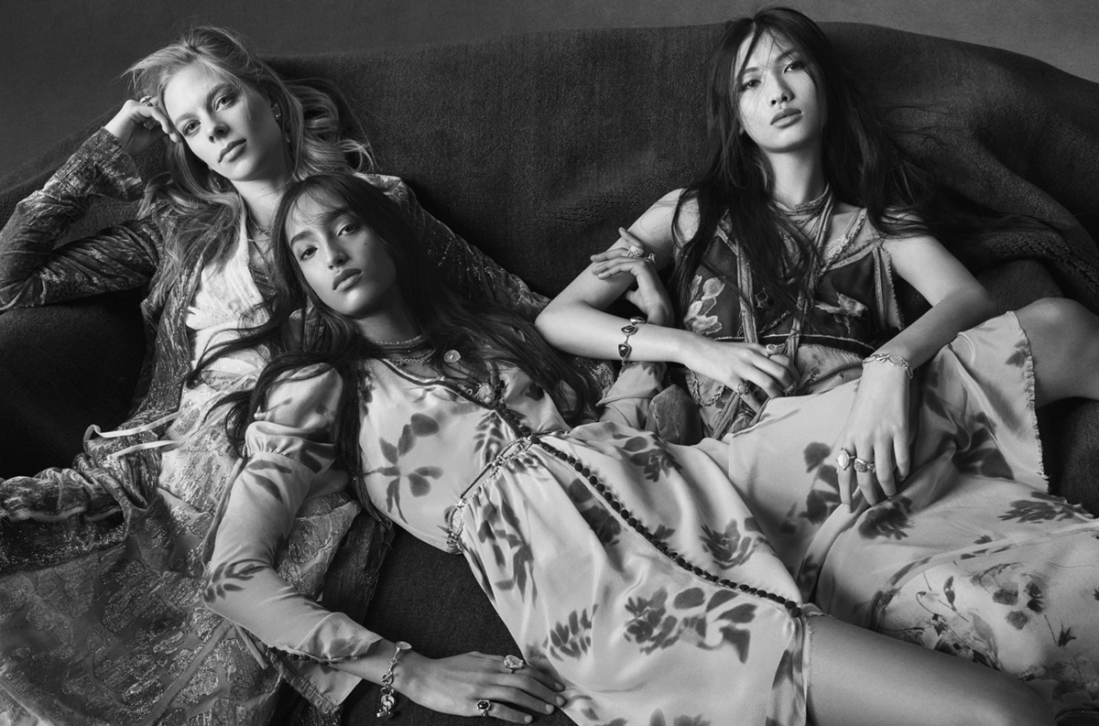

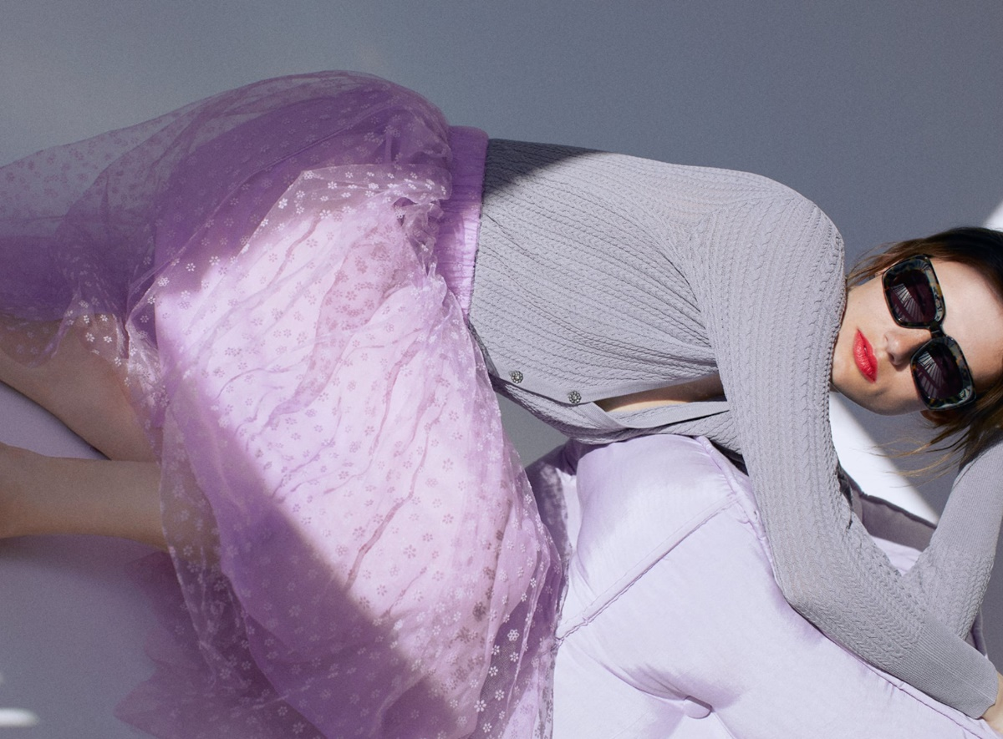

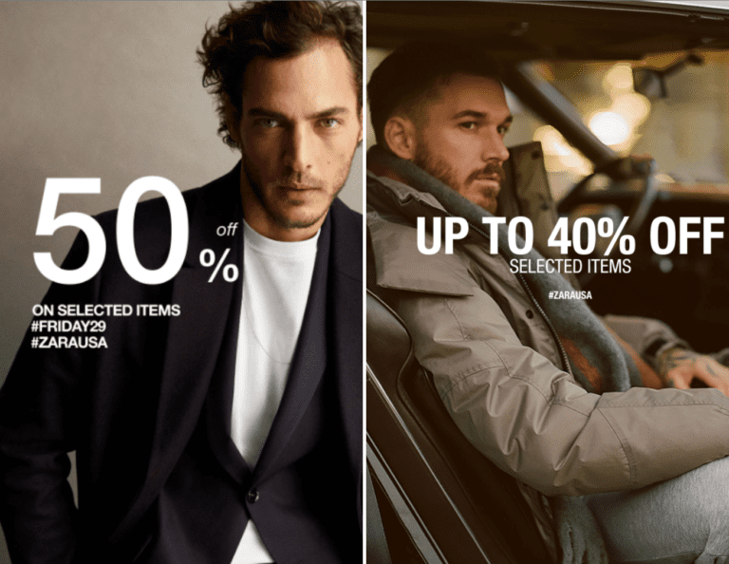

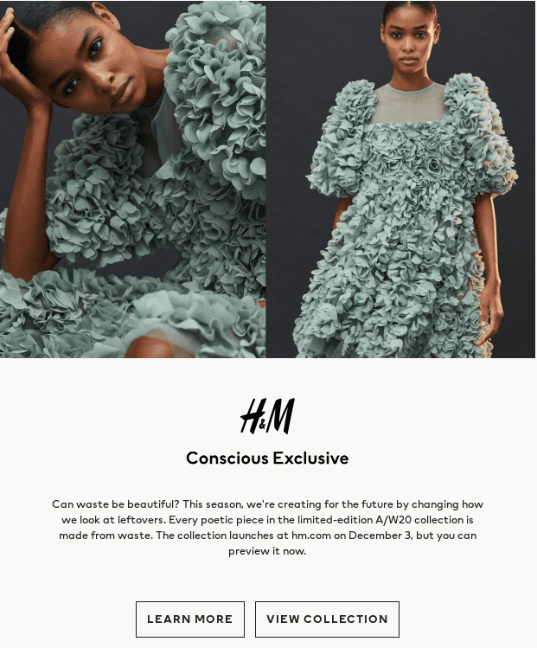

H&M always comes up with new products that increase the customer's desire for clothing, that too at an affordable cost. Their only notion is fashion and quality at the best price.

They have everything that a person may look for, from normal wear to business suits, sports wear to lingerie sets all at a reasonable price. They collaborate with other top brands to establish a fresh style. H&M collaborated with Karl Lagerfeld in 2004, Versace in 2011, Alexander Wang in 2014 and the collaboration with Balmain is the most triumphant to date.

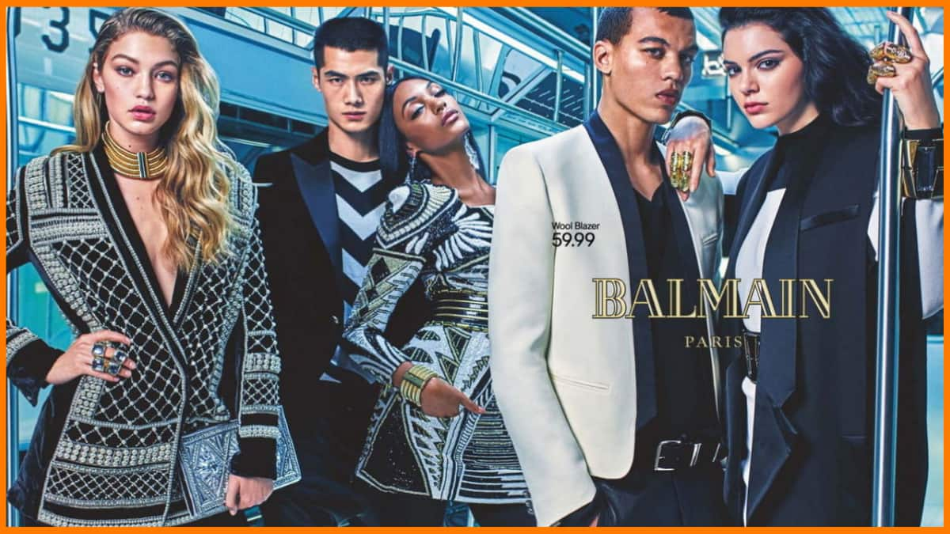

They also collaborated with the celebrated Indian designer Sabyasachi in 2021. The collection was named Sabyasachi x H&M.

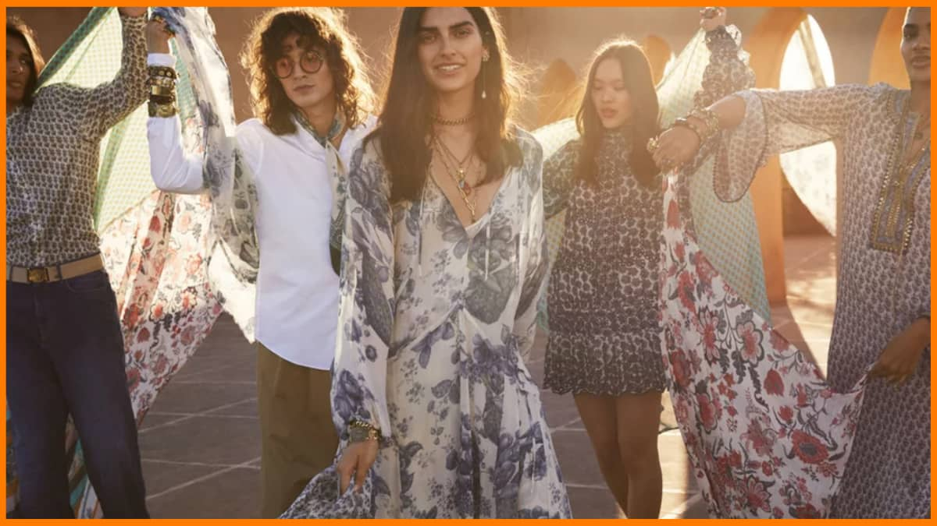

Before releasing the season's collection, they fuel the people's curiosity by promoting it on social media platforms. The brands mostly target the teens, to get their attention, they make sure their brand pops up in every online platform and publicize it by the influencers with a large following.

They feature models in different skin colors and sizes, giving the notion that fashion pertains to everyone irrespective of their skin color or size.